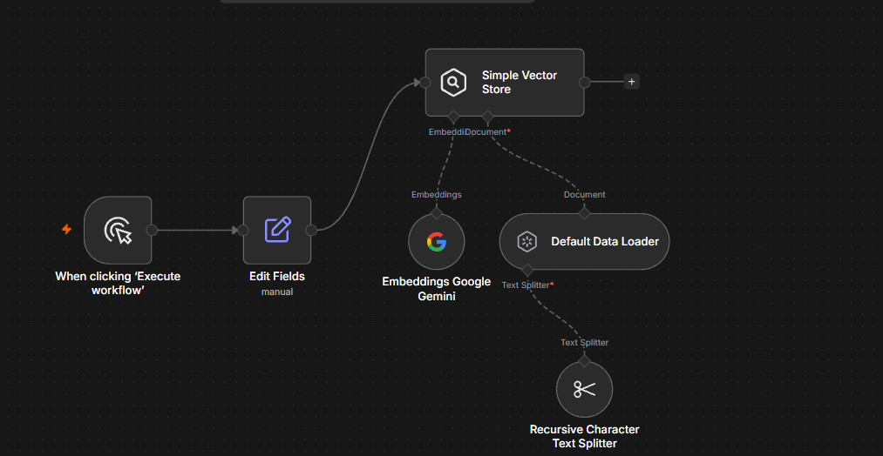
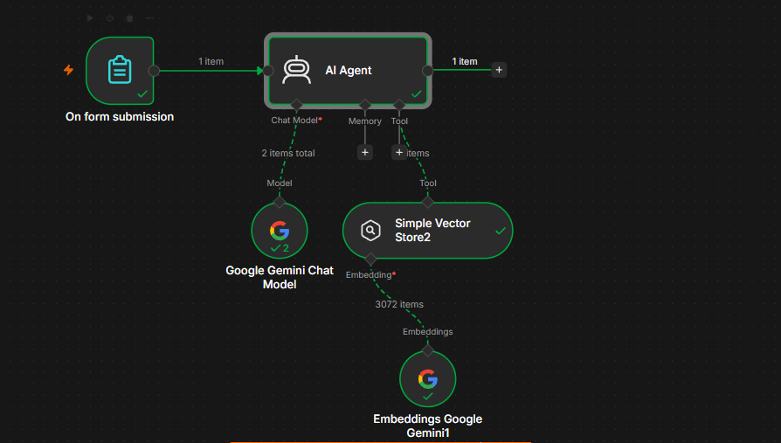

1. Project Overview
The AI HR Assistant is an AI-powered HR question-answering system built in n8n.
Employees submit their details and HR-related questions through an n8n Form. The AI Agent uses Google Gemini and searches a company HR policy knowledge base stored in a Simple Vector Store. It then provides an answer based on the available HR policy instead of making up information.
Example
Employee Question:
How many casual leave days are employees eligible for per year?
AI Answer:
According to the company's HR policy, employees are eligible for 12 casual leave days per calendar year.

2. Objectives
The main objectives are:
- Automate basic HR queries.
- Provide quick answers to employees.
- Use company HR policies as the knowledge source.
- Prevent the AI from inventing HR policies.
- Allow employees to submit questions through a form.
- Use vector search to retrieve relevant HR information.
- Provide professional and consistent responses.
- Handle questions that are not covered by the available policy.

3. Technologies Used
Technology | Purpose
n8n | Workflow automation
n8n Form Trigger | Collect employee questions
AI Agent | Understand and answer questions
Google Gemini Chat Model | Generate AI responses
Google Gemini Embeddings | Convert HR documents into vectors
Simple Vector Store | Store and retrieve HR policy information
Default Data Loader | Load HR policy documents
Recursive Character Text Splitter | Split policy into smaller chunks

4. Overall Architecture
The project contains two logical sections on the same n8n workflow canvas.
HR KNOWLEDGE BASE

Manual Trigger
↓
Edit Fields
↓
Simple Vector Store
↑ ↑
│ │
Gemini Default Data Loader
Embeddings ↑
│
Recursive Character Text Splitter

AI HR ASSISTANT

On Form Submission
↓
AI Agent
↑ ↑
│ │
Gemini │ Tool
Chat Model │
↓
Simple Vector Store 2
↑
│
Gemini Embeddings

5. Workflow Section 1 — HR Knowledge Base
This section is responsible for storing the company's HR policy.
Node 1: Manual Trigger
Node
When clicking 'Execute workflow'
Purpose
Used to manually execute the HR policy ingestion process during development/testing.
Flow
Manual Trigger
↓
Edit Fields

6. Node 2 — Edit Fields
Node
Edit Fields
Purpose
Stores the HR policy text that will be added to the vector database.
Field
Field Name:
hr_policy
Example Content
COMPANY HR POLICY

LEAVE POLICY

Employees are eligible for 12 casual leave days per calendar year.

Employees are eligible for 10 sick leave days per calendar year.

Leave requests should be submitted to the reporting manager for approval.

WORK FROM HOME POLICY

Employees may request up to 2 work-from-home days per week,
subject to manager approval.

Working from home does not remove the requirement to attend
scheduled meetings.

WORKING HOURS

Normal working hours are Monday to Friday, 9:00 AM to 6:00 PM.

Employees are expected to follow their assigned shift timings.

ATTENDANCE POLICY

Employees must record their attendance using the company's
attendance system.

ONBOARDING

New employees must complete the HR onboarding process and
submit all required documents.

PAYROLL

Salary is processed according to the company's payroll schedule.

Employees with questions about their individual salary or
deductions should contact HR or Payroll.

BENEFITS

Employees may be eligible for company benefits according to
their employment terms and applicable company policies.

7. Node 3 — Simple Vector Store
Node
Simple Vector Store
Operation Mode
Insert Documents
Memory Key
vector_store_key
Purpose
This node stores the processed HR policy as vector data.
The policy is converted into embeddings so that the AI can later search for information based on the meaning of the employee's question.
Important
The same memory key must be used by the retrieval side:
vector_store_key

8. Node 4 — Google Gemini Embeddings
Node
Embeddings Google Gemini
Purpose
Converts HR policy text into numerical vector representations.
For example:
"Employees get 12 casual leave days"
is converted into an embedding that allows the system to perform semantic searches.
Connection
Google Gemini Embeddings
↓
Simple Vector Store
Embedding

9. Node 5 — Default Data Loader
Node
Default Data Loader
Purpose
Converts the HR policy data into documents that can be processed by the vector store.
Connection
Default Data Loader
↓
Simple Vector Store
Document

10. Node 6 — Recursive Character Text Splitter
Node
Recursive Character Text Splitter
Purpose
Large HR documents are divided into smaller chunks before being converted into embeddings.
Configuration
Recommended:
Chunk Size: 1000
Chunk Overlap: 200
Connection
Recursive Character Text Splitter
↓
Default Data Loader
Text Splitter
This allows the vector search to retrieve the most relevant portions of the HR policy.

11. Knowledge Base Flow
The complete knowledge-base process is:
Manual Trigger
↓
Edit Fields
↓
HR Policy Text
↓
Default Data Loader
↓
Recursive Character Text Splitter
↓
Text Chunks
↓
Google Gemini Embeddings
↓
Simple Vector Store
↓
Stored HR Knowledge

12. Workflow Section 2 — AI HR Assistant
The second section handles employee questions.
Node 7 — On Form Submission
Node
On Form Submission
Purpose
Collects employee information and the HR question.
Form Fields
Field | Type | Example
Employee Name | Text | John
Employee ID | Text | EMP001
Department | Text | IT
HR Question | Text Area | How many casual leaves do I get?
Recommended
Use Text Area for the HR Question because employees may submit longer questions.

13. Example Form Submission
Employee Name:
John

Employee ID:
EMP001

Department:
IT

HR Question:
How many casual leave days are employees eligible for per year?
The form sends this information to the AI Agent.

14. Node 8 — AI Agent
Node
AI Agent
Purpose
The AI Agent acts as the HR assistant.
It:
- Receives the employee question.
- Understands the question.
- Decides whether HR policy information is required.
- Calls the HR Policy Search tool.
- Receives relevant policy information.
- Generates the final answer.

15. AI Agent Prompt
User Prompt
A suitable prompt is:
Employee Name:
{{ $json['Employee Name'] }}

Employee ID:
{{ $json['Employee ID'] }}

Department:
{{ $json['Department'] }}

Employee Question:
{{ $json['HR Question'] }}

Answer the employee's question.

For company-policy questions, use the HR Policy Search tool.

If the HR policy contains the answer, explain it clearly.

If the information cannot be found in the HR policy, say:

"I couldn't find this information in the available HR policy. Please contact HR for confirmation."

Do not invent an answer.

16. AI Agent System Message
Use:
You are an AI HR Assistant.

Your job is to answer employee HR questions using the company's HR policy.

IMPORTANT RULES:

1. Use the HR Policy Search tool for questions about company policies.
2. Do not invent HR policies.
3. Use retrieved HR policy information as the primary source.
4. If the policy does not contain the answer, say that the information is not available and recommend contacting HR.
5. Answer in simple, professional language.
6. Do not expose confidential employee information.
7. Do not make decisions about hiring, firing, promotion, compensation or disciplinary action.
8. Do not make decisions based on protected personal characteristics.
9. For individual employee records such as personal leave balance or salary, explain that HR/Payroll may need to verify the employee's records.

17. Node 9 — Google Gemini Chat Model
Node
Google Gemini Chat Model
Purpose
Provides the language model used by the AI Agent to understand questions and generate responses.
Connection
Google Gemini Chat Model
↓
Chat Model
↓
AI Agent

18. Node 10 — Simple Vector Store 2
The second vector store is used for retrieval, not insertion.
Operation
Retrieve Documents
(As Tool for AI Agent)
Memory Key
vector_store_key
This must match the memory key used in the insertion vector store.
Purpose
Searches the stored HR policy when the AI Agent needs information.

19. AI Agent Tool Connection
The connection should be:
AI Agent
│
│ Tool
↓
Simple Vector Store 2
Important
Do not connect the Vector Store to the normal AI Agent workflow line.
The Vector Store should be connected through the Tool input.

20. Retrieval Embeddings
The second:
Embeddings Google Gemini
is connected to the retrieval vector store.
Embeddings Google Gemini
↓
Simple Vector Store 2
Embedding
The embedding configuration should be compatible with the embeddings used when inserting the HR documents.

21. Complete AI Question Flow
When an employee submits a question:
Employee
↓
On Form Submission
↓
AI Agent
↓
AI Agent decides it needs HR policy
↓
HR Policy Search Tool
↓
Simple Vector Store 2
↓
Semantic Search
↓
Relevant HR Policy
↓
AI Agent
↓
Google Gemini
↓
Final Answer

22. Example 1 — Leave Question
Employee asks
How many casual leave days are employees eligible for per year?
Retrieved policy
Employees are eligible for 12 casual leave days per calendar year.
AI Response
According to the company's HR policy, employees are eligible
for 12 casual leave days per calendar year.

23. Example 2 — Sick Leave
Question
How many sick leave days are employees eligible for per year?
Expected Answer
According to the company's HR policy, employees are eligible
for 10 sick leave days per calendar year.

24. Example 3 — Work From Home
Question
How many work-from-home days can employees request per week?
Expected Answer
Employees may request up to 2 work-from-home days per week,
subject to manager approval.

25. Example 4 — Working Hours
Question
What are the normal working hours?
Expected Answer
The normal working hours are Monday to Friday,
9:00 AM to 6:00 PM.

26. Example 5 — Unknown Policy
Question
What is the company's maternity leave policy?
If maternity leave information is not included in the knowledge base, the AI should not invent an answer.
Expected response:
I couldn't find this information in the available HR policy.
Please contact HR for confirmation.
This is an important feature because it reduces hallucinated HR information.

27. Testing Checklist
Test the following questions:
Test | Question | Expected
Leave | How many casual leaves are available? | 12 days
Sick Leave | How many sick leaves are available? | 10 days
WFH | How many WFH days are allowed? | Up to 2 days
Working Hours | What are normal working hours? | 9 AM–6 PM
Attendance | How should attendance be recorded? | Attendance system
Onboarding | What is required during onboarding? | Required documents/process
Payroll | Who handles salary questions? | HR/Payroll
Unknown | What is maternity leave policy? | Contact HR

28. Important Configuration Notes
Memory Key
The two vector stores must use the same key:
vector_store_key
Embeddings
Use compatible embedding configuration for:
- Document insertion
- Document retrieval
Vector Store
Use:
Insert Documents for the knowledge-base side.
Use:
Retrieve Documents (As Tool for AI Agent) for the question-answering side.
Clear Store
When rebuilding your knowledge base during testing, you may use Clear Store to remove old data.
After clearing and inserting the correct HR policy, turn Clear Store OFF before normal use.

29. Common Problems and Solutions
Problem 1: AI says it doesn't know the answer
Check:
- Vector Store Tool is connected to AI Agent.
- Retrieval Vector Store uses the correct memory key.
- HR policy was actually inserted.
- Embeddings are working.
- The AI Agent has permission to use the tool.

Problem 2: AI retrieves unrelated information
This can happen when old documents are still stored under the same vector-store memory key.
Solution:
- Enable Clear Store on the insertion vector store.
- Execute the knowledge-base section.
- Confirm the HR documents are inserted.
- Disable Clear Store.
- Test the AI Agent again.

Problem 3: Embedding 404 error
If you see an error similar to:
404 Not Found
gemini-embedding-001
check:
- Google Gemini credential.
- Available embedding model.
- Model availability for your credential/region.
- Ensure insertion and retrieval use compatible embeddings.

Problem 4: AI Agent doesn't use the vector store
Check that the connection is:
AI Agent
↓
Tool
↓
Simple Vector Store 2
and not:
AI Agent → Simple Vector Store
through the normal workflow connection.

30. Security Considerations
An HR Assistant may handle sensitive employee information.
Therefore:
- Do not expose employee IDs unnecessarily.
- Do not expose salary information to unauthorized users.
- Do not allow the AI to make employment decisions.
- Restrict access to the workflow.
- Use only approved HR documents.
- Keep company policies up to date.
- Avoid storing unnecessary personal information.
- Use appropriate credentials and permissions.

31. Limitations
The current project uses Simple Vector Store, which is useful for learning and testing.
It is not the ideal choice for a production HR system because the stored data can be lost when the n8n instance restarts or the in-memory store is cleared.
For a production implementation, consider a persistent vector database such as:
- Qdrant
- Supabase
- Pinecone
- PostgreSQL with pgvector

32. Future Enhancements
The AI HR Assistant can be expanded with:
Employee Leave Balance
Connect to an HR database:
Employee ID
↓
HR Database
↓
Leave Balance
↓
AI Agent
Then the assistant could answer:
You have 7 casual leave days remaining.
HR Ticket Creation
If the AI cannot answer:
AI Agent
↓
Unknown Question
↓
Create HR Ticket
↓
Notify HR
Email Integration
Send HR responses through email.
Slack / Microsoft Teams
Allow employees to ask HR questions directly from workplace chat.
Document Upload
Allow HR administrators to upload:
- HR policies
- Employee handbook
- Benefits documents
- Leave policies
- Attendance policies
and automatically update the knowledge base.

33. Final Workflow Summary
Your completed AI HR Assistant consists of:
╔══════════════════════════════════════════════╗
║ HR KNOWLEDGE BASE ║
╠══════════════════════════════════════════════╣
║ Manual Trigger ║
║ ↓ ║
║ Edit Fields — HR Policy ║
║ ↓ ║
║ Simple Vector Store — Insert Documents ║
║ ↑ ↑ ║
║ Gemini Embeddings Default Data Loader ║
║ ↑ ║
║ Recursive Text Splitter ║
╚══════════════════════════════════════════════╝

╔══════════════════════════════════════════════╗
║ AI HR ASSISTANT ║
╠══════════════════════════════════════════════╣
║ On Form Submission ║
║ ↓ ║
║ AI Agent ←──── Google Gemini Chat Model ║
║ │ ║
║ │ Tool ║
║ ↓ ║
║ Simple Vector Store 2 ║
║ Retrieve Documents as AI Agent Tool ║
║ ↑ ║
║ Gemini Embeddings ║
║ ↓ ║
║ Relevant HR Policy ║
║ ↓ ║
║ AI-generated HR Answer ║
╚══════════════════════════════════════════════╝
Conclusion
The AI HR Assistant successfully combines n8n automation, Google Gemini, embeddings, vector search, and an AI Agent to provide policy-grounded HR assistance.
The key concept demonstrated by this project is RAG (Retrieval-Augmented Generation): instead of asking the AI to rely only on its general knowledge, the system retrieves relevant company policy information and uses it to generate the response. This makes the assistant more reliable for company-specific HR questions.

